Savitribai Phule Pune University

A FINAL PROJECT REPORT
ON
Smart Phone Application for
Smooth Path Detection

Submitted by
Abhishek Gaurav 71818146J
Prasad Mulherkar 71818448D
Viraj Hinge 71818318F
Aniket Patil 71818164G

Under the guidance of
Prof. S. S. Raskar Prof. J. S. Mane

Department of Computer Engineering
Modern Education Society’s
College Engineering, Pune-411 001
[2020-21]
MODERN EDUCATION SOCIETY’S
College of Engineering, Pune 01
C E R T I F I C A T E

This is to certify that the Project Entitled

SMART PHONE APPLICATION FOR
SMOOTH PATH DETECTION

Submitted by

Abhishek Gaurav 71818146J
Prasad Mulherkar 71818448D
Viraj Hinge 71818318F
Aniket Patil 71818164G

is a bonafide work carried out by Students under the supervision of Prof. S. S. Raskar and Prof. J. S. Mane and it is submitted towards the partial fulfillment of the requirement of Bachelor of Engineering (Computer Engineering).

(Prof. S. S. Raskar) (Prof. J. S. Mane)
Guide Guide
Department of Computer Engineering Department of Computer Engineering

(Dr. N. F. Shaikh) (Dr. S. S. Sarawade)
Head, Principal,
Department of Computer Engineering M.E.S. College of Engineering Pune – 01

Place : Pune

Date :

ACKNOWLEDGEMENT

It gives us great pleasure in presenting the final project report on ‘Smart Phone Application for Smooth Path Detection’. I would like to take this opportunity to thank my internal guide, Head of Computer Engineering Department, M.E.S. College of Engineering Pune 01, Prof. S. S. Raskar and Prof. J. S. Mane for giving us all the help and guidance I needed. I am really grateful to them for their kind support. Their valuable suggestions were very helpful. In the end our special thanks to B. E. project coordinators and our guides for providing valuable guidance for our project.

Abhishek Gaurav
Prasad Mulherkar
Viraj Hinge
Aniket Patil
(B. E. Computer Engineering)

ABSTRACT

Smart-phone Application for Smooth Path Detection works by utilizing the GPS and various sensors like tri-axial accelerometer, magnetometer, etc. of smart-phone. These sensors are used for analyzing the road irregularity, sharp turns, this data will be uploaded on centralized server so every application user can use this information during travelling. The implemented system is a route suggesting real-time Android Application. The system is based on Road Quality (measured previously) which tells about complexity of road on which we are driving. This complexity is based on sensors data and previous records while the GPS provides location. System is considering standard deviation of accelerometer for y and z axis respectively to determine the bumps and humps on the road. While the magnetometer deviation is used to identify the number of turns in route.

Using this information several alternatives will be suggested to the user where he/she can choose for one of the favorable route from source to destination based on road quality and time constraints. Using this system, we can do analysis of the road’s smoothness on the basis of number of potholes and bumps and number of turns for the desired path. System provides updated quality of the road to users and government bodies as well. Also, Road Managing Authorities like MSRTC can get advantage of this application to evaluate the state of their road network, and improve road quality.

TABLE OF CONTENTS

CHAPTER NO. |  |  | TITLE OF THE CHAPTER |  |  | PAGE NO.
1 |  |  | INTRODUCTION |  |  | 1
 | 1.1 |  | Motivation |  |  | 1
 | 1.2 |  | Problem Statement |  |  | 1
 | 1.3 |  | Introduction |  |  | 1
2 |  |  | LITERATURE SURVEY |  |  | 2
 | 2.1 |  | Literature Survey |  |  | 2
3 |  |  | SOFTWARE REQUIREMENTS SPECIFICATION |  |  | 3 - 7
 | 3.1 |  | Introduction |  |  | 3
 |  |  | 3.1.1 | Project Scope |  | 3
 |  |  | 3.1.2 | User Classes |  | 3
 |  |  | 3.1.3 | Use Case View |  | 3
 | 3.2 |  | Functional Requirements |  |  | 4
 | 3.3 |  | External Interface Requirements |  |  | 5
 |  |  | 3.3.1 | Software Interface Requirements |  | 5
 | 3.4 |  | Non-Functional Requirements |  |  | 5
 | 3.5 |  | Analysis Models : SDLC Model |  |  | 6
 | 3.7 |  | System Implementation Plan |  |  | 6 - 7
4 |  |  | SYSTEM DESIGN |  |  | 8 - 15
 | 4.1 |  | System Architecture |  |  | 8 - 9
 | 4.2 |  | Data Design |  |  | 9 - 12
 |  |  | 4.2.1 | Internal Software Data Structure |  | 9
 |  |  | 4.2.2 | Global Data Structure |  | 9
 |  |  | 4.2.3 | Temporary Data Structure |  | 10
 |  |  | 4.2.4 | Database Description |  | 10
 |  |  | 4.2.5 | Data Flow Diagram |  | 10 - 12
 | 4.3 |  | Entity Relationship Diagrams |  |  | 12 - 13
 |  |  | 4.3.1 | Data Description |  | 12
 |  |  | 4.3.2 | Data Objects and Relationship |  | 13
 |  |  | 4.3.3 | Entity - Relationship Diagram |  | 13
 | 4.4 |  | UML Diagrams |  |  | 14 - 15
 |  |  | 4.4.1 | Activity Diagram |  | 14
 |  |  | 4.4.2 | Class Diagram |  | 15
5 |  |  | PROJECT IMPLEMENTATION |  |  | 16 - 18
 |  | 5.1 | Project Overview |  |  | 16
 |  | 5.2 | Project Requirements |  |  | 17
 |  | 5.3 | Algorithms |  |  | 17 - 18
 |  |  | 5.3.1 |  | K-Means Algorithm | 17
 |  |  | 5.3.2 |  | Evaluation | 17 - 18
6 |  |  | TESTING |  |  | 19 - 20
 |  | 6.1 | Types of Testing |  |  | 19
 |  |  | 6.1.1 |  | Performance Testing | 19
 |  |  | 6.1.2 |  | System Testing | 19
 |  |  | 6.1.3 |  | Recovery Testing | 19
 |  |  | 6.1.4 |  | Unit Testing | 19
 |  |  | 6.1.5 |  | Black Box Testing | 19
 |  |  | 6.1.6 |  | Integration Testing | 19
 |  | 6.2 | Test Cases & Test Results |  |  | 20
7 |  |  | RESULTS |  |  | 21 - 26
 |  | 7.1 | Experimental Results |  |  | 21
 |  | 7.2 | Screenshots |  |  | 21 - 26
 |  |  | 7.2.1 |  | Web Server | 21 - 24
 |  |  | 7.2.2 |  | Android Application | 25 - 26
8 |  |  | OTHER SPECIFICATION |  |  | 27
 | 8.1 |  | Advantages |  |  | 27
 | 8.2 |  | Limitations |  |  | 27
 | 8.3 |  | Applications |  |  | 27
9 |  |  | CONCLUSIONS & FUTURE WORK |  |  | 28
 |  | 9.1 | Conclusion |  |  | 28
 |  | 9.2 | Future Work |  |  | 28
 |  |  | Appendix A : Problem statement feasibility assessment using, satisfy ability analysis and NP Hard, NP-Complete or P type using modern algebra and relevant mathematical models.  Appendix B: Details of the papers referred in IEEE format (given earlier) Summary of the above paper in not more than 3-4 lines. Here you should write the seed idea of the papers you had referred for preparation of this project report.  Appendix C: Plagiarism Report |  |  | 29 - 30  31  32 - 34
 |  |  | REFERENCES |  |  | 35

LIST OF ABBREVIATIONS
Abbreviation | Illustration
GPS | Global Positioning System
IRI | International Roughness Index

LIST OF FIGURES
Figure | Illustration | Page No.
3.1 | Use Case Diagram | 4
3.2 | Waterfall Model | 6
4.1 | Architecture Diagram | 9
4.2 | DFD Level – 0 | 10
4.3 | DFD Level – 1 | 11
4.4 | DFD Level – 2 | 12
4.5 | Entity Relationship Diagram | 13
4.6 | Activity Diagram | 14
4.7 | Class Diagram | 15
5.1 | Working Overview Diagram | 16
7.1 | Readings of SD_{z}(i), SD_{yz}(i) and B_{yz}(i) at instance ‘i’ | 21
7.2 | Web Server Landing Page | 21
7.3 | Admin Login Page | 22
7.4 | Admin Registration Page | 22
7.5 | Phone Analysis Page | 23
7.6 | Trend Graph of Data Readings | 23
7.7 | Statistical Analysis of Data Readings | 24
7.8 | View all records | 24
7.9 | Start Page | 25
7.10 | Menu Page | 25
7.11 | Starting Map | 25
7.12 | Sensor Reading | 25
7.13 | Output for Route 1 | 26
7.14 | Output for Route 2 | 26

LIST OF TABLES
Table | Illustration | Page No.
6.2.1 | Test Case Table | 20
C.1 | Plagairism Report Table | 32

1. INTRODUCTION

1.1 MOTIVATION
- Nowadays we all use Google maps and its application for navigation during travelling increasing safety and comfort.
- It helps us to find routes with shortest path and minimum traffic.
- But these applications may not be able to tell us any road’s condition or its complexity.

1.2 PROBLEM STATEMENT
To develop an application to detect the road bump and pothole present on road. In this system initially admin get the data by using various sensors of android phone. Using that one text file is generated. This is send to the server for analyzing the data. After analysis server gets the detailed condition of the road on map to the user.

1.3 INTRODUCTION
In today’s world smart-phones can be listed as one of the necessities. Everyone uses smart-phone for work, education, etc. In the Pandemic the use of smart-phones increased very much as their importance as well. Smart-phones can be used for collection of the data which is a low cost and easy to use in today’s world. In addition to Smart-phone’s potentially wide population coverage as probe devices they are embedded with various sensors like Accelerometer, Gyroscope, etc. In the previous systems, various sensors were used and they were attached to vehicles with predetermined orientation. This has been done to estimate road roughness where promising results have been observed.
This application system will take a next step by attempting to estimate road roughness from Smart-phones under extreme realistic settings, which is beyond particular orientation, i.e. the Smart-phone will be loosely fixed inside the monitoring vehicle. Avoiding the bad road condition is a very difficult and challenging task. One of the reasons is that the task requires the precise collection of substantial data and also the amount of road network condition data, which is very important for maintenance, planning and monitoring over time, in addition to the considerable efforts that have to be directed to actual maintenance of the road network.

2. LITERATURE SURVEY

2.1 LITERATURE SURVEY
The study conducted by Amita Dhiman and Reinhard Klette [1] Techniques for identifying potholes on road surfaces aim at developing strategies for real-time or offline identification of potholes, to support real-time control of a vehicle (for driver assistance or autonomous driving) or offline data collection for road maintenance. Some of them are gear shifts and overall road conditions which consist of bumps, rough road, uneven road, and smooth road.
The study conducted by Chellaswamy C [2] an internet of things based road monitoring system (IoTRMS) is proposed to identify the potholes and humps in the road. The IoT-RMS automatically updates the status of the road with location information in the cloud. Each road vehicles can access the information from the server and estimate the speed according to the potholes and humps present on the road.
Pit-free: Pot-holes detection on Indian Roads using Mobile Sensors by Gaurav Singal [3] proposes a system which makes use Smart-phone sensors (such as Accelerometer and gyroscope) to identify the pot-holes on road and GPS for the location of the pit. In this system SVM (Support Vector Machine) had been used to classify the raw data.
The study conducted by Azza Allouch [4] is to create a real-time Android Application Road Sense that automatically predicts the quality of the road based on tri-axial accelerometer and gyroscope, show the road location trace on a geographic map using GPS and save all recorded workout entries. A Decision tree classifier is applied on training data to classify road segments and to build our model.
M. Ghadge et al. [6] used an accelerometer and GPS to analyze the conditions of roads to detect locations of potholes and bumps using a machine learning approach, defined by K-means clustering on training data and a random-forest classifier for testing data. The data is divided first into two clusters of “pothole” or “non-pothole”, and then a random forest classifier is used to validate the proposed result provided by the clustering algorithm. It is reported that clustering does not perform well when clusters of different size and severity are involved; size and severity of a pothole are the major properties considered in the system.

3. SOFTWARE REQUIREMENT SPECIFICATION

3.1 INTRODUCTION
3.1.1 Project Scope
Nowadays we all use Google maps and its application for navigation during travelling, but these applications couldn't able to tell you any road's condition or its complexity. Quality and Complexity analysis of roads using android phone proposes to utilize the GPS system of phone and different sensors like accelerometer, magnetometer, etc. of android phone, so we could analyze the road and can upload this information of that road on centralized server so every application user can use this information during traveling.[4] Android apps like “AdroSensor” can be used to collect data from smart phone sensors for this purpose. This information can be helpful to user at the time if there are multiple routes and for destination and he can choose one of the finest and shortest route.

3.1.2 User Classes
- User
- User will login to app.
- User will choose alternative route if road condition is bad.
- User would be able to access the system whenever he requires.
- Admin
- Admin can find bumps on the road using accelerometer sensor and sends data to the server.
- Admin can calculate the number of turns on the road using magnetometer.

3.1.3 Use Case View
A use case diagram is a simple representation of a user's interaction with the system that shows the relationship between the user and the different use cases in which the user is involved.

Figure 1 : Use Case Diagram

3.2 FUNCTIONAL REQUIREMENTS
The following technical requirements were chosen as a basis for this application system :
  - System should be able to detect bumps in real time.
  - Collection of raw data for offline post-processing is an additional feature.
  - Smart phone must have the accelerometer and GPS sensors.
  - The system running on a smart-phone should be able to perform its native communication tasks at an adequate quality level.
  - Vehicle type should not affect the data collection process.

3.3 EXTERNAL INTERFACE REQUIREMENTS
3.3.1 Software Interface Requirements
- JDK 8 :
The Java Development Kit (JDK) is a software development environment used for developing Java applications and applets. It includes the Java Runtime Environment (JRE), an interpreter/loader (java), a compiler (javac), an archiver (jar), a documentation generator (javadoc) and other tools needed in Java development.
- MySQL Database :
Web application will require storing large amounts of metadata and keep data organized. Therefore there was a need to host a Java web application with MySQL.
- Eclipse :
Eclipse is an open source community whose projects building tools and frameworks are used for creating general purpose application. The most popular usage of Eclipse is as a Java development environment.
- Android :
Android software development is the process by which new applications are created for the Android operating system. Applications are usually developed in the Java programming language using the Android Software Development Kit, but other development tools are available.
- Apache Tomcat Server :
It is currently one of the most widely used application servers in the market. As a matter of fact, many of today’s applications and virtually all web services can be built on top of Tomcat with a variety of add-ons and pluggable services readily available in the market. It is no secret that many developers acknowledge that Tomcat is usually a much better choice to build today’s deployment and development architectures than other servers.

3.4 NONFUNCTIONAL REQUIREMENTS
- High Speed : System should process requested task in parallel for various action to give quick response then system must wait for process completion.
- Accuracy : The system should correctly execute the process. Finally the original retinal image is first pre-processed and then particle analysis is performed.
- Interoperability : System should have the ability to exchange information and communicate with internal and external applications and systems. It must be able exchange information both internally and externally.
- Reliability : System should be delivering specified and required data only.
- Response Time : The response time of the system should be deterministic at all times and very low, i.e. it should meet every deadline. Thus, the system will work in real time.

3.5 ANALYSIS MODELS : Waterfall Model
Figure 2 : Waterfall Model

3.6 SYSTEM IMPLEMENTATION PLAN
- Requirement gathering and analysis:
All the functional and non-functional requirements of the project were identified. Interaction with the users and all other stakeholders of the project was conducted to identify all the requirements starting from important features like maintaining audit trail, security parameters etc. to the very basic features like the look and the feel of user interface.

- System Design:
- Business entities layer: It identifies all the entities used in the project.
- Business logic layer: This layer operates on the business entity to achieve the goals.
- Data access layer: This layer serves as an interface between backend and the services.
- Implementation:
All modules and user interface was built in this step. Development was done using Java. Database was constructed in MySQL.
- Testing:
All the modules were integrated together. The user interface was integrated with the modules which made the use web services. Data flow originated from the database built in MySQL. In testing phase project was tested and debugged. Various test cases were developed and the project was tested at the developers end as well as users end. Debugging was done to discover errors and exception which were corrected.
- Deployment of System:
Once the functional and nonfunctional testing is done, the product is deployed in the customer environment or released into the market.
- Maintenance:
There are some issues which come up in the client environment. To fix those issues patches are released. Also to enhance the product some better versions are released. Maintenance is done to deliver these changes in the customer environment. All these phases are cascaded to each other in which progress is seen as owing steadily downwards like a waterfall through the phases. The next phase is started only after the defined set of goals are achieved for previous phase and it is signed off, so the name "Waterfall Model". In this model phases do not overlap.

4. SYSTEM DESIGN

4.1 SYSTEM ARCHITECTURE
Using smart-phones to collect the data is a promising alternative because of its low cost and easy to use feature in addition to this, it’s potentially wide population coverage as probe devices. In our previous study we explored the used of smart-phones, fixed to vehicles with predetermined orientation, to estimate road roughness where promising results have been observed. This project will take a further step by attempting to estimate road roughness from smart-phones under extreme realistic settings, which is beyond fixed orientation and/or fastening the devices themselves tightly with vehicles while collecting data. In other words, the smart-phone are placed loosely at locations that a driver would be more likely to put their smart-phones inside a car while driving.
- Bump Detection : Rock bottom layer of the system is on the appliance running on the Smartphone. The application collects data from the accelerometer, magnetometer and GPS then processes this to detect braking and bump events. It then attaches a time and site tag to the present event data, and sends it across to the online server for further processing. Bump is detected using sensor data gathered from admin phone, details of location of bump is stored on the server side for other users.
- Finding Road complexity : As we have seen the data which we get from accelerometer and magnetometer, in that we consider y-axis for turns detection, here we calculate the angle of ‘Y-axis’ with the north direction by which we can get how much car is turned at right or left side. For this we also consider the previous angle of ‘Y-axis’ with north direction. This helps to count the number of turns in specific alarm, and also we can conclude how much they are tough.
- Evaluation of Road at Server Side : The REST web service on the server receives the event traces of several Smartphone's along with the time and location tags. Using this information, the web service infers higher level of evaluation such as road is smooth or it is with too much speed bump, roads are too complex or they are easy to drive, etc.

- Make data available to Other users : The web service needs to send over the inferred events to the Smartphone running the application. The Smartphone sends over its location, and the web service responds with events of interests in the vicinity of this location. These events are displayed on a map on the phone, so that the user of the application can choose to take alternate routes based on this.

Figure 1 : Architecture diagram

4.2 DATA DESIGN
MySQL database is used in the whole system to manage and store details of each attribute of all samples in file formats.

4.2.1 Internal Software Data Structure
Data structures that are passed among components the software are described.

4.2.2 Global Data Structure
Data structured that are available to major portions of the architecture are described.

4.2.3 Temporary Data Structure
Files created for interim use are described.

4.2.4 Database Description
The database basically used for storing user details like username and password. The tool used for db functionalities was MySQL GUI Software. The system's GUI was designed using java swing. Core Technologies used were Java. The overall development was done in the Eclipse IDE.
- The primary function of the database server is to securely store data in itself and when third party applications request for its retrieval give permission for the same.
- Simplified connection wizard.
- Guided installation to JDBC driver.
- Writing executing SQL queries.
- Editing and deployment of stored procedure.

4.2.5 Data Flow Diagram
A data flow diagram (DFD) is a graphical representation of the flow of data through an information system, modeling its process aspects. It shows data is processed by a system in terms of inputs and outputs.

Level 0 Data Flow Diagram
A context diagram is a top level (also known as Level 0) data flow diagram. It only contains one process node (Process 0) that generalizes the function of the entire system in relationship to external entities.
Figure 2 : DFD0
Level 1 Data Flow Diagram
DFD level 1 diagram. It expands the DFD 0 and shows the detailed flow in the proposed system. It shows the different processes that take place to perform the authentication.

Figure 3 : DFD1

Level 2 Data Flow Diagram
It expands the DFD 1 and shows the detailed flow in the proposed system.

Figure 4 : DFD2

4.3 ENTITY RELATIONSHIP DIAGRAM
4.3.1 Data Description
Data objects used in the system are : Tables and columns are used to attributes and multiple tables store multiple data items. Processing items are internally generated and processed by regretting two modules.

4.3.2 Data Objects and Relationships
Data objects and their major attributes and relationships among each others are described using an ER diagram. ER diagram is a data model for describing the data or information aspects of a software system. The main components of ER models are entities and the relationships that exists among them. The various entities of the synchronization system are :
  - User
  - Admin
  - System

4.3.3 Entity Relationship Diagram

Figure 5 : Entity Relationship Diagram

4.4 UML DIAGRAMS
4.4.1 Activity Diagram
Activity diagrams are graphical representations of workflows of stepwise activities and actions with support for choice, iteration and concurrency.

Figure 6 : Activity Diagram

4.4.2 Class Diagram
Class diagram shows the structure of the classes, attributes, operations and relationship among them. Given below is the class diagram of the proposed system. The class diagram showed below, includes in all 6 classes which describe the structure of proposed system.

Figure 7 : Class Diagram

5. PROJECT IMPLEMENTATION

5.1 PROJECT OVERVIEW
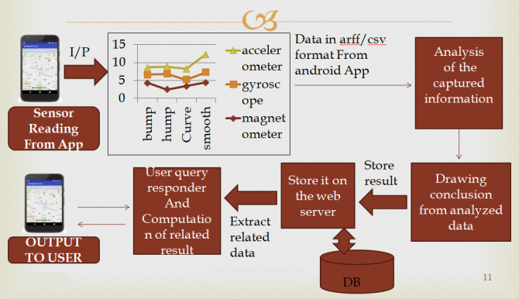
Figure 1 : Working Overview Diagram

In the working, first we will setup our Android Application in our Smart-phones. We will start taking the data readings from the application using Smart-phone sensors like Accelerometer, Gyroscope, Magnetometer for the desired travelling route. Once the route is completed we get our text file of readings with the decisions of the road roughness like ‘bad road’, ‘bump’, ‘left turn’, etc. While in the same network as of server we send our file over to our centralized server.

We have admin access to the server. Admin have options to change the decisions from the text file, if nothing to change then approve the file. It then will be stored onto our database i.e. MySQL.

When any user will search for the route from the application, it sends a request to centralized server asking that the quality of the road is present or not. If present the response is sent with the details of bumps, humps, turns, etc. with their respective geo-locations. Then it is plotted onto the Android Map. If the data is not present then it will start taking readings for that route and analyze the route considering it a new route. As soon as it comes with the connection with server the file gets uploaded over to server for future works.

5.2 PROJECT REQUIREMENTS
Software Used : Eclipse, MySQL Workbench, Xampp, Apache Server, Android Studio, Google Maps API’s
Hardware Used : Android Sensors, Wifi Adapters, Core i5, RAM - 8GB, 1TB HDD
Operating System : Windows 10 (64-bit), Android 10
Programming Languages : Java (Version 8), HTML, JavaScript, SQL

5.3 ALGORITHMS
5.3.1 K-Means Algorithm
K-Means Clustering is an Unsupervised Learning algorithm, which groups the unlabeled dataset into different clusters. Here K defines the number of pre-defined clusters that need to be created in the process, as if K=2, there will be two clusters, and for K=3, there will be three clusters, and so on.

It allows us to cluster the data into different groups and a convenient way to discover the categories of groups in the unlabeled dataset on its own without the need for any training.

It is a centroid-based algorithm, where each cluster is associated with a centroid. The main aim of this algorithm is to minimize the sum of distances between the data point and their corresponding clusters.

The algorithm takes the unlabeled dataset as input, divides the dataset into k-number of clusters, and repeats the process until it does not find the best clusters. The value of k should be predetermined in this algorithm.

5.3.2 Evaluation
Based on the experiment result, road bump detection logic is designed as follows:

Condition 1 : Both of the Y-axis or running direction and Z-axis or vertical direction, 50[ms] Standard deviation is large.

Condition 2 : The sections are appeared with wheel base time. Here, each variable is defined as follows. A recording order number is defined by ‘i’. An acceleration data are defined by X(i), Y(i), Z(i) for each axis. For Y-axis or running direction and Z-axis or vertical direction, 50[ms] standard deviation is defined as SD_{y}(i), SD_{z}(i). For the condition 1, simultaneity index is defined as SD_{yz}(i), and it is calculated by Equation1,

fSD_{yz}(i) = SD_{y}(i) * SD_{z}(i) ... Equation1

Cycle number of wheelbase time is defined by Nw. For the condition 2, Bump Index is defined by B_{yz}(i), and it is calculated by Equation 2,

fB_{yz}(i) = SD_{yz}(i) * SD_{yz}(i + N_{w}) ... Equation2

Nw is related with vehicle speed. Vehicle speed is defined as V [m/s]. Wheelbase is defined by Lw [m]. Recording cycle is defined H [Hz]. Nw is calculated by Equation 3,

fN_{w} = (L_{w} / V) * H ... Equation3

6. TESTING

6.1 TYPES OF TESTING
6.1.1 Performance Testing
The performance of the algorithm is measured by comparing it with future data readings taken in the realistic settings.

6.1.2 System Testing
Checked the speed of the system when just 1 hour of readings taken for analysis and plotting graphs. The working speed gets slower and slower as the sensors take 40 readings per second.

6.1.3 Recovery Testing
If the system crashes, then it can be up and running within 2 hours. But there is no special autonomous functionality given to it. The process will be manual.

6.1.4 Unit Testing
All the modules are independently handled, developed and ran to get proper output and finally they are integrated to get the whole output.

6.1.5 Black Box Testing
Compatibility analysis is done by passing the output of one module to another and checking for estimated output.

6.1.6 Integration Testing
All the modules are combined to form our system ‘Smooth Path Detection’ and tested for desired output.

6.2 Test Cases and Test Results
Description | Test Case | Input | Actual Output | Expected Output
Orientation Test 1 | Bump Detection | Positive elevated reading than standard deviation. | Bump | Bump
Orientation Test 2 | Hump Detection | Negative elevated reading than standard deviation. | Hump | Hump
Orientation Test 3 | Bump Detection | Positive elevated reading than standard deviation. | Bump | Normal Road
Orientation Test 4 | Turn Detection | Deflection of Y-axis in North-East | Right Turn | Right Turn
Orientation Test 5 | Turn Detection | Deflection of Y-axis in North-West | Left Turn | Left Turn

7. RESULTS

7.1 EXPERIMENTAL RESULTS
The logic explained earlier is applied onto the collected data. The 50[ms] standard deviation of Z-axis acceleration or vertical direction SD_{z}(i) is drawn in following figure, Simultaneity index SD_{yz}(i) is drawn in figure, and Bump index B_{yz}(i) is drawn below:

Figure 1 : Readings of SD_{z}(i), SD_{yz}(i) and B_{yz}(i) at instance ‘i’.

Users get the choice of route based on factors like the quality of the road, maintenance status, accident prone roads, etc. User can choose the road according to his/her relevance.

7.2 SCREENSHOTS
7.2.1 Web Server

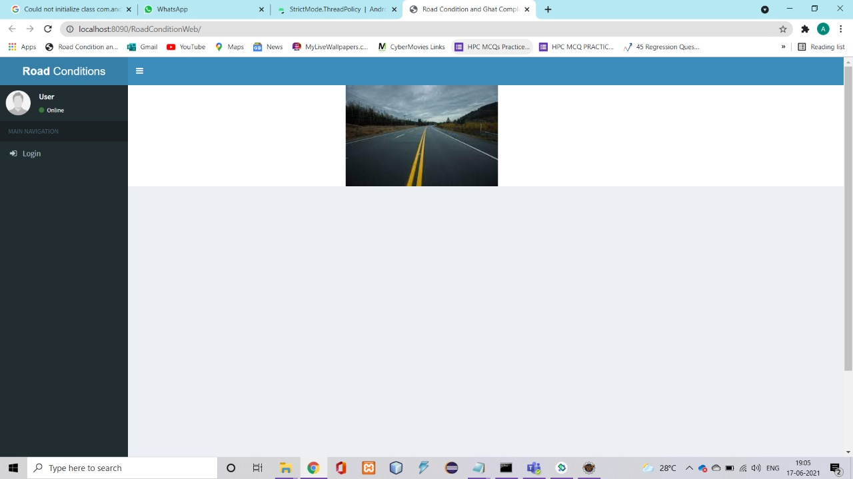
Figure 2 : Web Server Landing Page

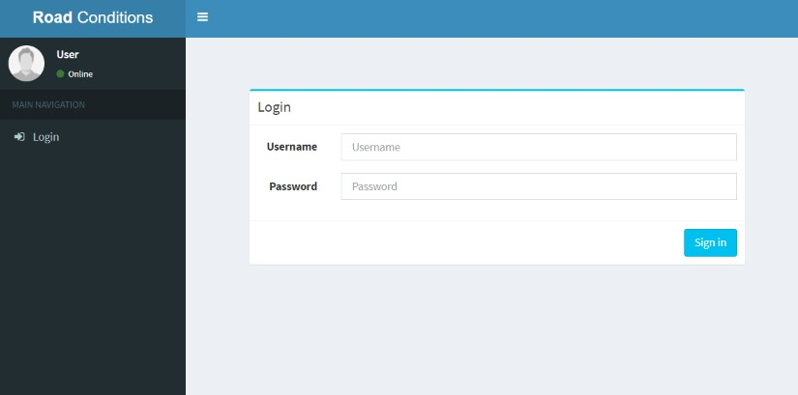
Figure 3 : Admin Login Page

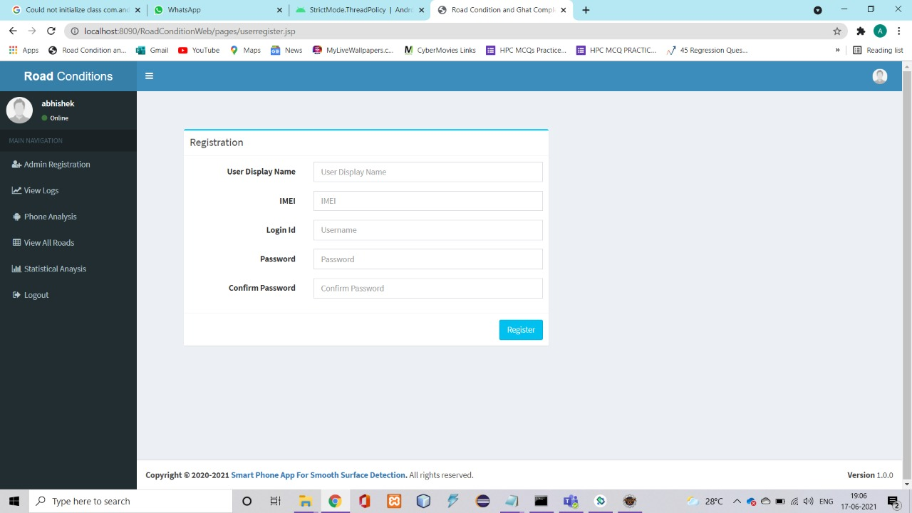
Figure 4 : Admin Registration Page

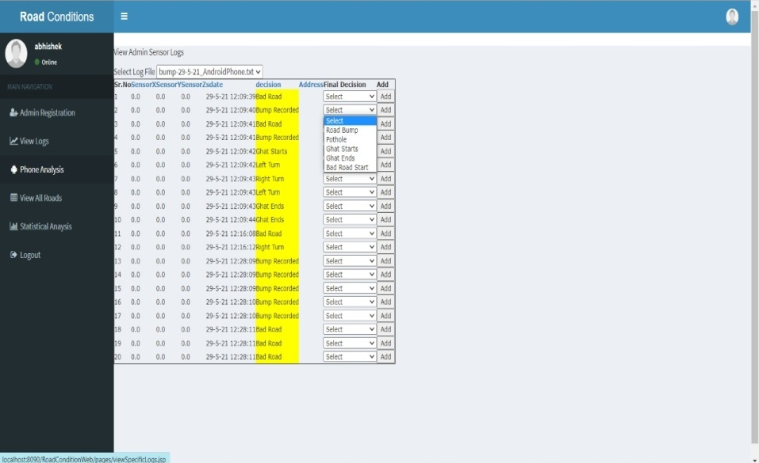
Figure 5 : Phone Analysis Page

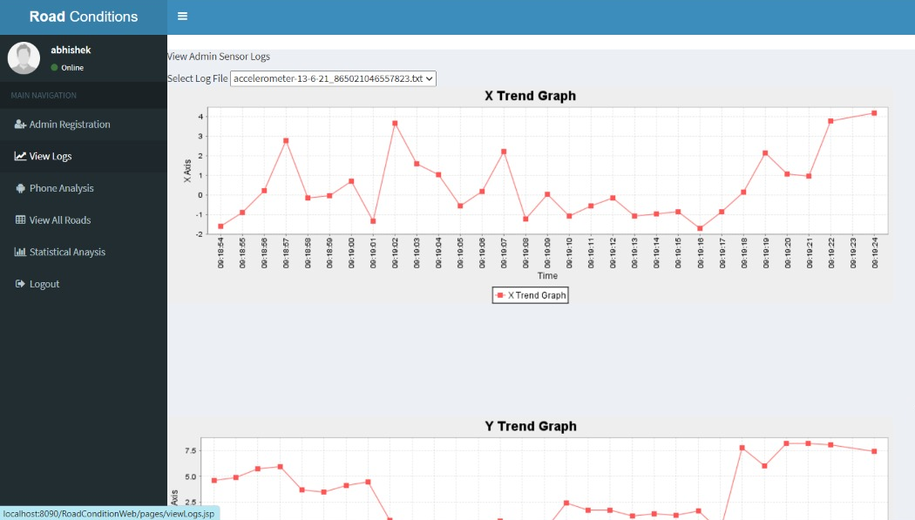
Figure 6 : Trend Graph of Data Readings

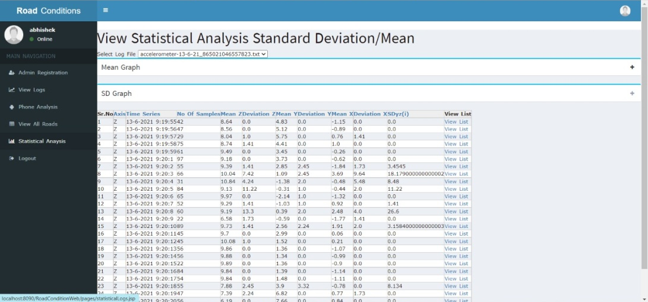
Figure 7 : Statistical Analysis of Data Readings

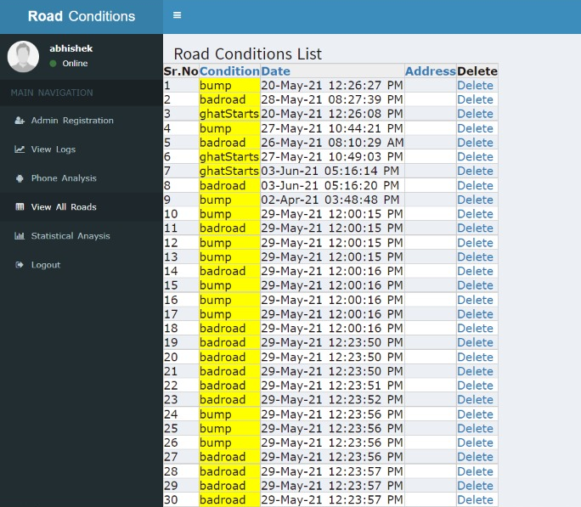
Figure 8 : View All Records Page

7.2.2 Android Application

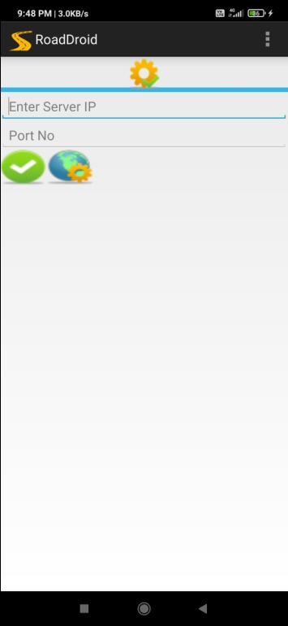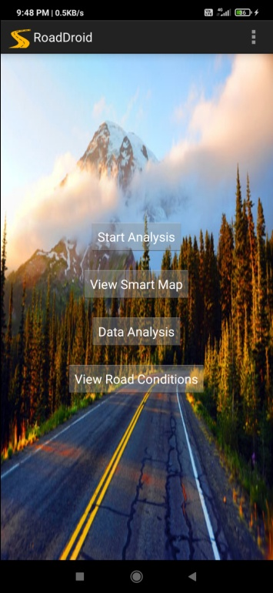
Figure 9 : Start Page Figure 10 : Menu Page

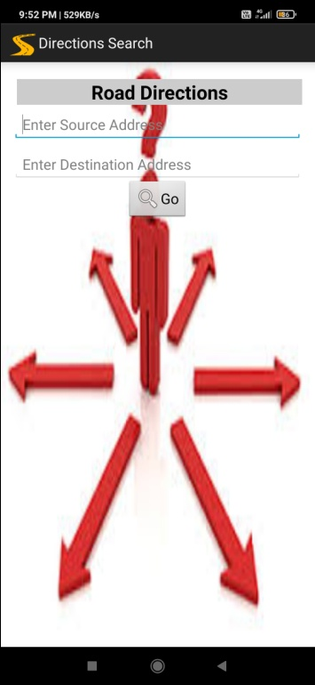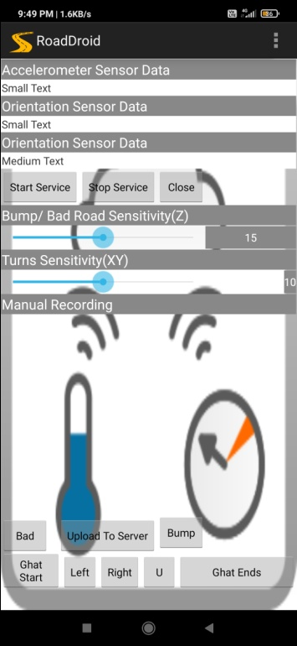
Figure 11 : Starting Map Figure 12 : Sensor Reading

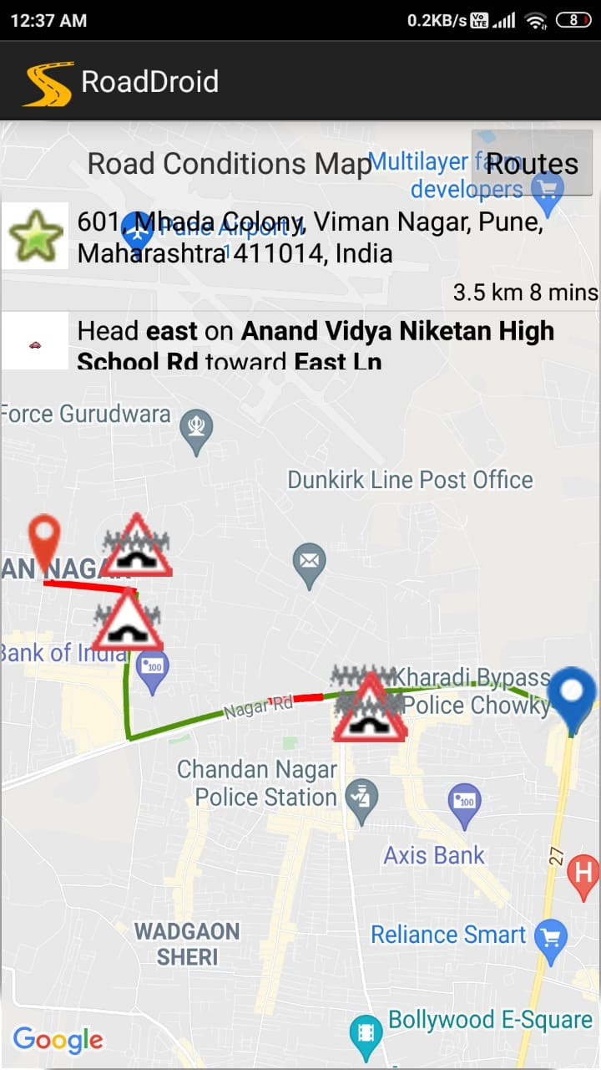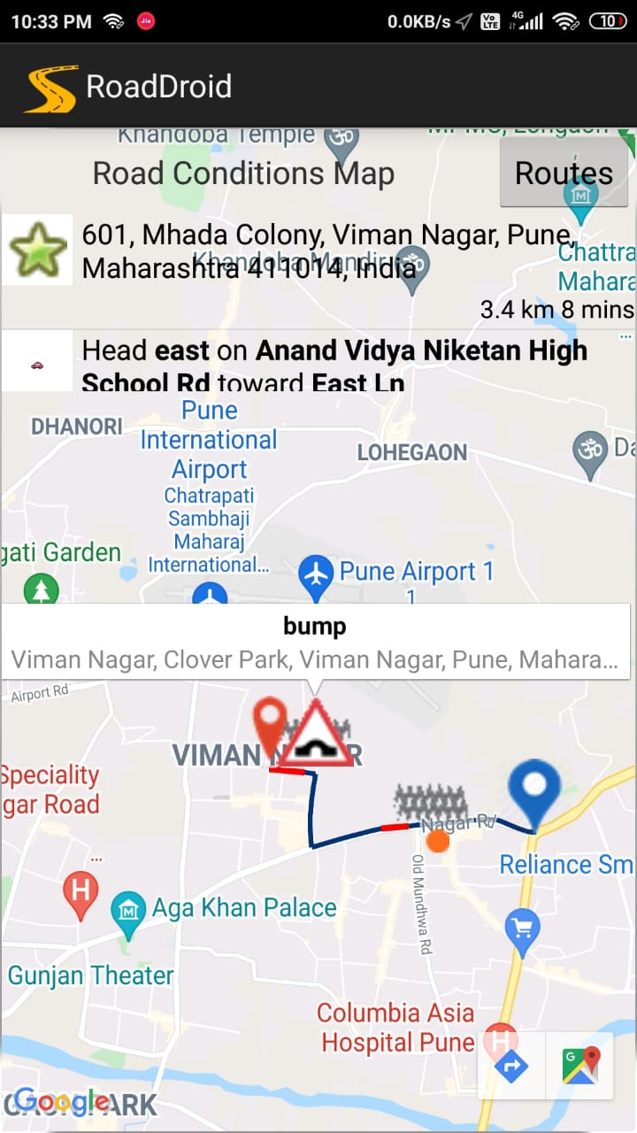
Figure 13 : Output for Route 1 Figure 14 : Output for Route 2

8. OTHER SPECIFICATIONS

8.1 ADVANTAGES
- This system will help user for faster and safer traveling.
- Requires no additional sensors.
- Low cost solution with realistic readings.
- Accuracy increases every time a new reading comes up for same travelled route.
- No predefined orientation required for the Smart-phones.

8.2 LIMITATIONS
- Less Accuracy.
- For uploading data to server, Smart-phone and server should be connected to same network.
- Constant GPS tracking needed, which might not be possible in bad network area.
- For free access of Google Map API’s we are limited with 20,000 API hit calls.

8.3 APPLICATIONS
- To navigate from one place to another with the best quality road.
- Detect the bumps and humps on traveling route with their precise location.
- Detect bad road condition on the route.
- Government bodies can notice and repair the roads with very bad quality.

9. CONCLUSION AND FUTURE WORK

9.1 Conclusion
Successful data collection has been done using Smart-phone sensors like Accelerometer, Gyroscope and Magnetometer to detect roughness of road as bumps, humps and no. of turns on the road. By means of our system ‘Smart Phone Application for Smooth Path Detection’, admin would evaluate the road and be able to upload this data of that road on centralized server so every application user can use this information during travelling. After a certain point every application user can act as admin and can upload data to the server. It also provides information that can be helpful to user at the time if there are multiple routes for destination and he can choose one of the good quality routes. And for the worst condition of roads the details can also be seen by respective officials.

9.2 Future Scope
In future we will try to reduce the error rate of the existing system for correct road quality estimation. And starting and ending of the route is automatically detected in future. The system can be upgraded to perform collaborative analysis of road complexity by extracting data from various diverse sources. The system can be hosted on cloud platform in future to scale it on larger levels.

APPENDIX A : Project problem statement feasibility assessment using NP - Hard, NP - Complete or satisfy ability issues using modern algebra and/or relevant mathematical models.

NP-Hard problem :
- NP-Complete and NP-Hard are: A decision problem is in P if there is a known polynomial-time algorithm to get that answer. The collection of all problems that can be solved in polynomial time is called P. That is, a decision question is in P if there exist an exponent k and an algorithm for the question that runs in time O (nk) where n is the length of the input.
- A decision problem is in NP if there is a known polynomial-time algorithm for a Non-deterministic machine to get the answer. The estimation cannot be solved in fixed time or we cannot define their execution complexity with a mathematical algorithm, are called as Non-Deterministic polynomial problems. Therefore, the problem becomes a decision problem, so it is NP.

NP-COMPLETE
- The collection of all problems that can be solved in polynomial time using non-deterministic is called NP. That is, a decision question is in NP if there exists an exponent k and a non-deterministic algorithm for the question that for all hints runs in time O (nk) where n is the length of the input.
- Detection of bumps and finding ghat complexities with evaluation of road can be done in polynomial time but it requires infinite time for DB interaction.
- All project algorithms can be determined in polynomial time but requires indefinite time for db interaction. Hence all db _le handling projects are NP-COMPLETE.

FEASIBILITY ASSESSMENT:
- Step 1 : Inserting data of products: This is P class problem because the insertion process can be done in polynomial time.
- Step 2 : Storing data in the database: Project algorithm can be determined by polynomial time but it requires indefinite time for db interaction hence it is NP-Complete problem.
- Step 3 : Testing Phase: The testing phase sends the product sample for testing to tester. This Process is done within a finite amount of time hence belongs to a P class Problem.
- Step 4 : Result Generation: After testing the test results are sent to respective authorities and the whole process belongs to P - class problem.

APPENDIX B : Details of the papers referred in IEEE format (given earlier) Summary of the above paper in not more than 3-4 lines. Here you should write the seed idea of the papers you had referred for preparation of this project report in the following format.

Pothole Detection Using Computer Vision and Learning: Application to detect pothole using accelerometer IEEE transaction 2019.

IoT Based Humps and Pothole Detection on Roads and Information Sharing : Application to detect humps using accelerometer IEEE transaction 2018.

Pitfree: Pot-holes detection on Indian Roads using Mobile Sensors IEEE transaction 2018.

Road Sense: Smartphone Application to Estimate Road Conditions using Accelerometer and Gyroscope IEEE transaction 2017.

Road Disturbance Estimation and Cloud-Aided Comfort-Based Route Planning IEEE transaction 2017.

Machine Learning Approach for Predicting Bumps on Road IEEE conference paper 2015.

Formulation of a Simple Model to Estimate Road Surface Roughness Condition from Android Smartphone Sensors conference paper 2017.

APPENDIX C : Plagiarism Report

Plagiarism Report :

Report Section | Unique Percentage
Abstract | 100
Introduction | 91
Proposed System | 100
Conclusion | 100
Total | 97.75

Respective Reports :

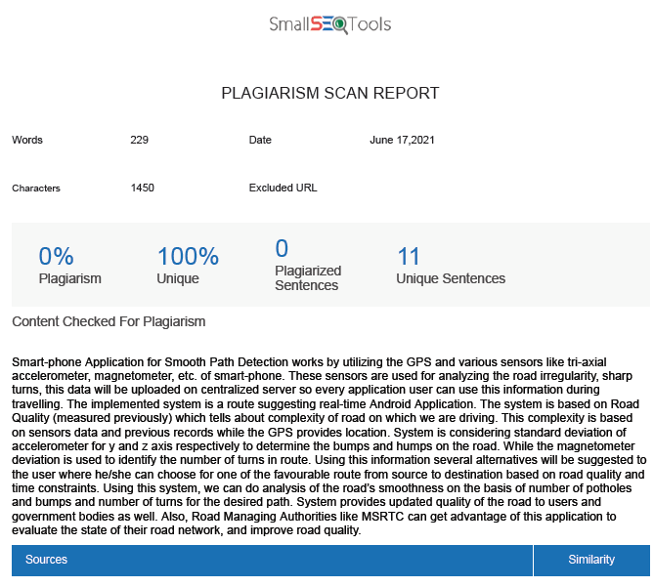

Plagiarism report of Abstraction



Plagiarism report of Introduction

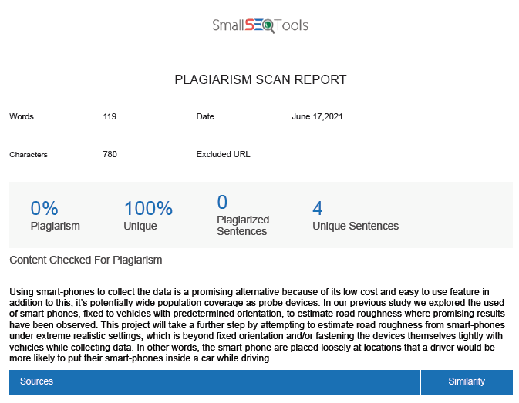
Plagiarism report of Proposed System

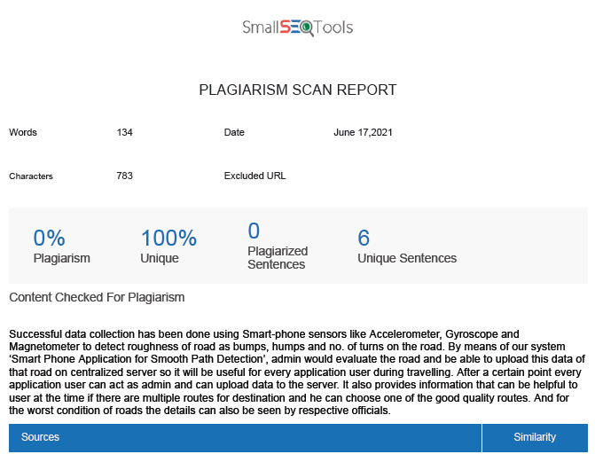
Plagiarism report of Conclusion

REFERENCES

- Pothole Detection Using Computer Vision and Learning: Application to detect pothole using accelerometer IEEE transaction 2019.

- IoT Based Humps and Pothole Detection on Roads and Information Sharing : Application to detect humps using accelerometer IEEE transaction 2018.

- Pitfree: Pot-holes detection on Indian Roads using Mobile Sensors IEEE transaction 2018.

- Road Sense: Smartphone Application to Estimate Road Conditions using Accelerometer and Gyroscope IEEE transaction 2017.

- Road Disturbance Estimation and Cloud-Aided Comfort-Based Route Planning IEEE transaction 2017.

- Machine Learning Approach for Predicting Bumps on Road IEEE conference paper 2015.

- Formulation of a Simple Model to Estimate Road Surface Roughness Condition from Android Smartphone Sensors conference paper 2017.

